Problem Statement
Weekly Product Review Pulse — Problem Statement
We are building an automated weekly “pulse” that turns public App Store and Google Play reviews for selected fintech products into a one-page insight report and delivers it to stakeholders through Google Workspace, using MCP (Model Context Protocol) so that writes to Google Docs and Gmail go through dedicated MCP servers—not ad hoc API calls inside the agent.
Supported products (initial): INDMoney, Groww, PowerUp Money, Wealth Monitor, Kuvera.

Objective
Give product, support, and leadership teams a repeatable, weekly snapshot of what customers are saying in store reviews: themes, representative quotes, and actionable ideas—without manual copy-paste or one-off spreadsheets.

What the system does
- Ingest public reviews from the last 8–12 weeks (configurable window) from both Apple App Store (e.g. iTunes customer-reviews RSS) and Google Play (scraper-based), per product.
- Cluster and rank feedback using embeddings and density-based clustering (e.g. UMAP + HDBSCAN), then use an LLM to name themes, pull verbatim quotes, and propose action ideas—with validation so quotes must appear in real review text.
- Render a concise one-page narrative: top themes, quotes, action ideas, and a short “who this helps” section.
- Deliver outputs only through Google Workspace MCP servers:
  - Google Docs MCP — append each week’s report as a new dated section to a single running document per product (e.g. Weekly Review Pulse — Groww). The Doc is the system of record and preserves history.
  - Gmail MCP — send a short stakeholder email that includes a deep link to the new section in that Doc (heading link), not a duplicate full report in email alone.
Internal code stays modular along these lines:
Concern | Where it lives
Data retrieval | Ingestion modules (App Store + Play Store)
Reasoning | Clustering + LLM summarization (themes, quotes, actions)
Output generation | Report + email rendering (structured for Docs and HTML/text for Gmail)
Human-visible delivery | MCP tools only → Google Docs MCP + Gmail MCP
The agent is an MCP host/client; it does not embed Google credentials or call the Docs/Gmail REST APIs directly for delivery.

Key requirements
- MCP-based delivery: Append to the shared Google Doc and send Gmail only via the respective MCP servers’ tools (e.g. document batch update, draft/create/send flows as defined in architecture).
- Weekly cadence: Designed to run once per product per week (e.g. scheduled job Monday morning IST), with a CLI for backfill of any ISO week.
- Idempotent runs: Re-running the same product + ISO week must not create duplicate Doc sections or duplicate sends. This is enforced with a stable section anchor in the Doc and a run-scoped idempotency check on email (see architecture).
- Auditable: Each run records delivery identifiers (e.g. doc heading / message ids) and enough metadata to answer “what was sent when, for which week?”
- Safety and quality: PII scrubbing on review text before LLM and before publishing; reviews treated as data, not instructions; cost/token limits per run.

Non-goals (explicit)
- A generic Google Workspace product beyond what the pulse needs (Docs append + Gmail send/draft).
- Real-time streaming analytics or a BI dashboard (the running Google Doc is the living artifact).
- Social sources (Twitter, Reddit, etc.) in the initial scope.
- Storing Google OAuth secrets in the agent codebase—they belong in the MCP servers’ configuration, per architecture.

Who this helps
Audience | Value
Product | Prioritize roadmap from recurring themes
Support | Spot repeating complaints and quality issues
Leadership | Fast health snapshot tied to customer voice

Sample output (illustrative)
Groww — Weekly Review Pulse
Period: Last 8–12 weeks (rolling window)
Top themes
- App performance & bugs — Lag, crashes during trading hours; login/session timeouts.
- Customer support friction — Slow responses; unresolved tickets.
- UX & feature gaps — Confusing navigation for portfolio insights; missing advanced analytics.
Real user quotes
- “The app freezes exactly when the market opens, very frustrating.”
- “Support takes days to reply and doesn’t solve the issue.”
- “Good for beginners but lacks detailed analysis tools.”
Action ideas
- Stabilize peak-time performance — Scale infra during market hours; improve crash visibility.
- Improve support SLA visibility — Expected response time in-app; ticket status tracking.
- Enhance power-user features — Advanced portfolio analytics; clearer investments navigation.
What this solves
Same intent as today: roadmap alignment for product, issue clustering for support, and a leadership-friendly snapshot—now automated, archived in Google Docs, and announced by email with a link back to the canonical section.

Delivery expectations (stakeholder-facing)
- Each run adds one clearly labeled section to the product’s pulse Google Doc (dated / week-labeled).
- The email is a brief teaser (e.g. top themes as bullets) plus a “Read full report” link to that section.
- Development/staging may default to draft-only email until explicit confirmation to send, per implementation plan.

Diagram Flow
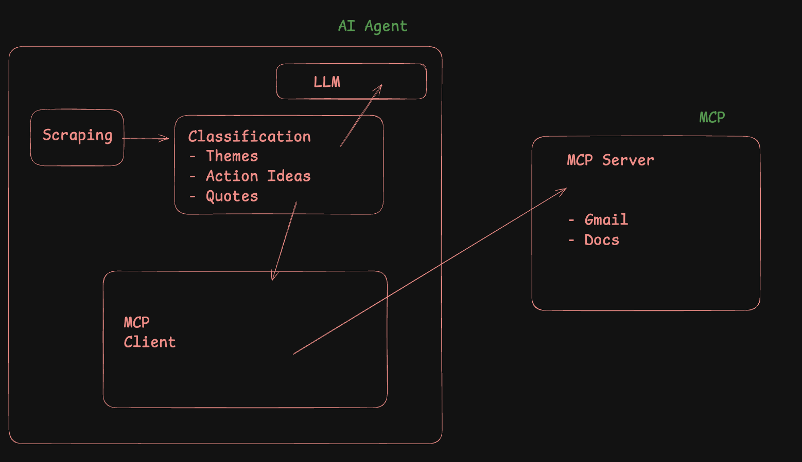

Steps

AI Agent
- Context
- Implement → PHASE 3

MCP server
OPTION 1 →
Saksham-mcp-server → https://github.com/saksham20189575/saksham-mcp-server

Option 2 →
PROMPT →

Build me a complete MCP-style server in Python that integrates with
Google Docs and Gmail.

📁 Project Structure:
google-mcp-server/
├── server.py → FastAPI app with tool endpoints
├── auth.py → Google OAuth authentication
├── docs_tool.py → Google Docs tool (append content)
├── gmail_tool.py → Gmail tool (create draft)
├── requirements.txt → All dependencies
├── README.md → Setup and usage instructions
├── credentials.json → (NOT committed — downloaded from Google Cloud)
└── token.json → (NOT committed — auto-generated after OAuth)

⚙️ Features to Build:

1. server.py
- Use FastAPI + uvicorn
- Create two POST endpoints:
* POST /append_to_doc → accepts doc_id and content, appends text to a Google Doc
* POST /create_email_draft → accepts to, subject, body and creates a Gmail draft
- Before executing any action, print the action name and payload in the
terminal and ask: "Approve? (y/n)" — only proceed if user types y

2. auth.py
- Use Google OAuth 2.0 with these scopes:
* https://www.googleapis.com/auth/documents
* https://www.googleapis.com/auth/gmail.compose
- Load credentials from credentials.json
- Save token to token.json after first login
- If token.json exists, load it directly (skip browser login)

3. docs_tool.py
- Function: append_to_doc(doc_id: str, content: str)
- Use Go

STEPS →
- Before running we need to do necessary steps on console.google.com
- Generate credentials.json → Credentials → Create a Oauth Client
- Run locally the MCP project to get Token.json
- For running MCP server → Run auth.py so that tokens can be generated
- For Token.json to be generated test user in audience we need to enter
Enter your email in Test user →
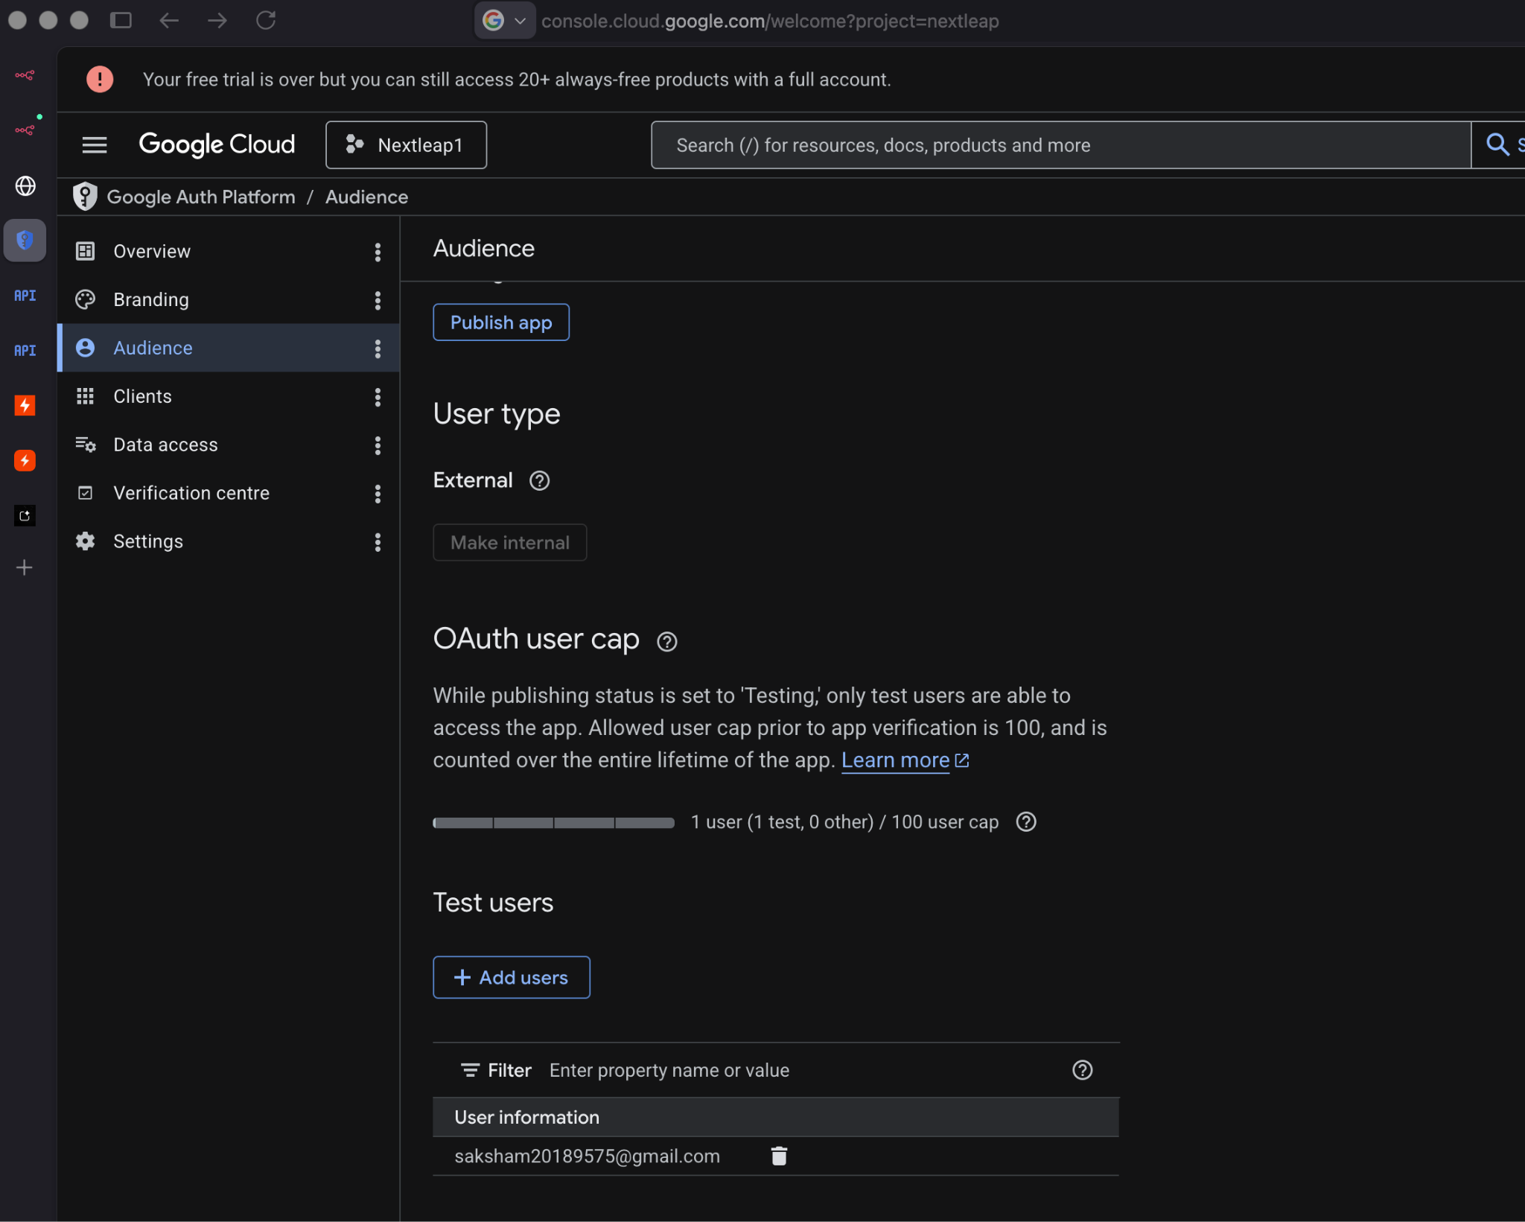

- Generate a deployment plan for this MCP server so that I can deploy it on Railway
- Do necessary changes for deploying this on railway
Save deployment plan in md file as well

Prompts
- Generate a problemStatement.md which stores the necessary context for the @docs/problemStatement.txt
- Currently we will build it for Groww platform only we can take only play store reviews MCP server we will create and provide in this project so that it can use it
Update all this in @docs/problemStatement.md
- Generate a detailed architecture.md using the @docs/problemStatement.md
- Generate a phase-wise implementation-plan.md using @docs/architecture.md and @docs/problemStatement.md
- Generate an edge-case.md file which contains all the corner cases for the project
- Implement phase0 as per the @docs/implementation-plan.md
- Implement phase1 as per the @docs/implementation-plan.md
- We can normalize the reviews in phase1
1. remove all the reviews with less than 8 words
2. remove all the reviews which have emoji's or are in another language
- Keep one file for all the actual reviews, one for all the normalized reviews
reviewId, userName, userImage, reviewCreatedVersion, at, replyContent, repliedAt
All these things we can remove
- regenerate the entire cache for 10 weeks
- Understand the normalized @data/cache/groww/2026-06-07/reviews_normalized.json and then decide if Preprocessing & clustering are correct in phase2 @docs/implementation-plan.md or not
- llama-3.3-70b-versatile
Request per minute - 30
Requests per Day - 1K
Tokens per minute - 12K
Tokens per day - 100K
These are the limits for 2b for LLM, we will be using Groq
Update both 2a and 2b in the @docs/implementation-plan.md based on above research
- Implement phase2 as per the @docs/implementation-plan.md
- why are we using open-AI
- We can use bge-small model rather than open-ai model
generate .env.example
- Run phase2
- Implement phase3 as per the @docs/implementation-plan.md
- Run phase3
- Currently the MCP we are using does not support formatting in the google doc so we can just append the content, make necessary changes in phase3
- For phase4 and phase5 we have already created MCP server
<MCP Server Link>
We will use this MCP server in our project so update @docs/architecture.md and @docs/implementation-plan.md for phase4 and phase5
- Implement phase4 as per the @docs/implementation-plan.md
This contains the details of the MCP server we created - https://github.com/saksham20189575/mcp-server-saksham/
/append_to_doc POST Append text to a Google Doc
/create_email_draft POST Create a Gmail draft
https://github.com/saksham20189575/mcp-server-saksham/blob/main/README.md
- Run phase4
- Implement phase5 as per the @docs/implementation-plan.md in the same way as we did for google docs
- Run phase5

Architecture
Weekly Product Review Pulse — Architecture
This document describes the technical architecture for the Groww Play Store review pulse: components, data flows, MCP integration, idempotency, and operational concerns. It extends problemStatement.md.

1. Goals and Constraints
Goal | Architectural implication
Weekly insight report from Play Store reviews | Batch pipeline, not streaming
Google Doc as system of record | Append-only sections with stable anchors
Email as notification, not duplicate report | Teaser + deep link to Doc heading
MCP-only delivery to Google Workspace | Pulse agent never holds Google OAuth or calls REST directly
Idempotent weekly runs | Run ledger + deterministic section keys
Auditable history | Persist run metadata and delivery IDs
Safe LLM usage | PII scrubbing, quote validation, token/cost caps
Current scope: Groww · Google Play Store · Google Docs MCP + Gmail MCP (both in this repo).

2. System Context
Stakeholders
This Repository
External
Google Play Store
Google Workspace APIs
Groq API
llama-3.3-70b-versatile
OpenAI Embeddings API
Pulse CLI / Scheduler
Pulse Agent
MCP Host
Play Store Ingestion
Analysis Pipeline
Report & Email Renderer
Run Ledger
Google Docs MCP Server
Gmail MCP Server
Weekly Review Pulse — Groww
Google Doc
Stakeholder Inboxes
The pulse agent orchestrates ingestion, analysis, rendering, and delivery. It connects to in-repo MCP servers as an MCP client. Google credentials and API access are confined to those servers.

3. Logical Layers
Layer 4 — Delivery (MCP)
Layer 3 — Output Generation
Layer 2 — Reasoning
Layer 1 — Data Retrieval
Play Store Scraper
Review Normalizer
PII Scrubber
Embedder
UMAP + HDBSCAN
Groq Summarizer
Quote Validator
Doc Section Builder
Email Teaser Builder
Docs MCP Tools
Gmail MCP Tools
Layer | Responsibility | Must not
Data retrieval | Fetch and normalize Play Store reviews for Groww | Call Google Workspace APIs
Reasoning | Cluster, summarize, validate quotes | Write to Docs or Gmail
Output generation | Build structured Doc blocks and email HTML/text | Hold Google OAuth
Delivery | Append Doc section, send/draft email | Contain clustering/LLM logic

4. Repository Layout (Proposed)
m3_6/
├── docs/
│ ├── problemStatement.md
│ └── architecture.md
├── config/
│ ├── products/
│ │ └── groww.yaml # Play Store app id, doc id, recipients
│ ├── pipeline.yaml # window weeks, cluster params, LLM limits
│ └── mcp/
│ ├── docs-mcp.env.example
│ └── gmail-mcp.env.example
├── mcp-servers/
│ ├── google-docs-mcp/ # MCP server: Docs append, heading lookup
│ └── gmail-mcp/ # MCP server: draft, send, idempotency keys
├── pulse/
│ ├── cli.py # Entry: run, backfill, dry-run
│ ├── agent/
│ │ ├── orchestrator.py # End-to-end run coordinator
│ │ └── mcp_client.py # MCP host wiring
│ ├── ingestion/
│ │ ├── play_store.py # Scraper + pagination
│ │ ├── normalizer.py # Quality filters (words, language, emoji)
│ │ ├── cache.py # reviews_raw / reviews_normalized cache
│ │ └── models.py # Review, RawReview, RunContext
│ ├── pipeline/
│ │ ├── scrubber.py # PII redaction
│ │ ├── embeddings.py
│ │ ├── clustering.py # UMAP + HDBSCAN
│ │ ├── summarizer.py # LLM theme/quote/action generation
│ │ └── quote_validator.py # Substring match against source reviews
│ ├── render/
│ │ ├── doc_section.py # Structured blocks for Docs MCP
│ │ └── email_teaser.py # HTML + plain text teaser
│ └── ledger/
│ ├── store.py # SQLite or JSON run ledger
│ └── models.py # RunRecord, DeliveryRecord
├── data/ # gitignored: cached reviews, run artifacts
└── tests/

This layout keeps MCP servers, the pulse pipeline, and configuration separable while shipping everything from one repo.

5. End-to-End Run Flow
Gmail MCPDocs MCPRun LedgerRendererPipelineIngestionOrchestratorPulse CLIGmail MCPDocs MCPRun LedgerRendererPipelineIngestionOrchestratorPulse CLIalt[already completed][new or failed retry]run --product groww --iso-week 2026-W23check idempotency(groww, 2026-W23)prior delivery idsskip (no-op success)fetch_reviews(window=8-12w)Review[]analyze(reviews)PulseReport(themes, quotes, actions)build_outputs(report, iso_week)DocSection, EmailTeaserappend_section(doc_id, anchor, blocks)heading_id, doc_url_fragmentsend_or_draft(teaser, deep_link, idempotency_key)message_id / draft_idrecord_run(metadata, delivery_ids)success + audit summary
Run inputs
Parameter | Description | Example
product | Product slug | groww
iso_week | ISO 8601 week | 2026-W23
window_weeks | Rolling review window | 10 (within 8–12 configurable range)
dry_run | Skip MCP writes | false
email_mode | draft or send | draft in staging
Run outputs (audit record)
{
"run_id": "groww-2026-W23-abc123",
"product": "groww",
"iso_week": "2026-W23",
"review_count": 872,
"window_weeks": 10,
"started_at": "2026-06-08T03:30:00+05:30",
"completed_at": "2026-06-08T03:42:11+05:30",
"doc_delivery": {
"document_id": "...",
"section_anchor": "groww-2026-W23",
"heading_id": "...",
"url": "https://docs.google.com/document/d/...#heading=..."
},
"email_delivery": {
"mode": "draft",
"message_id": "...",
"idempotency_key": "groww-2026-W23-email"
},
"status": "completed"
}

6. Play Store Ingestion
Responsibilities
- Resolve Groww’s Play Store listing from product config (play_store_app_id or package name).
- Scrape public reviews within the configured date window (8–12 weeks).
- Paginate until window boundary or no more pages.
- Normalize to a canonical Review model.
Review models
Raw cache (reviews_raw.json) — full scrape payload per review:
Field | Type | Notes
text | string | Raw review body
rating | int | 1–5 stars
published_at | datetime | UTC; used for window filtering
Normalized pipeline input (reviews_normalized.json, Review in models.py) — what Phase 2 consumes:
Field | Type | Notes
text | string | Review body passing quality filters
rating | int | 1–5 stars
Phase 1 normalization (before cache write): ≥8 words, English-only (allowed_language: en), no emoji. Typical Groww pull: ~800–900 normalized reviews from ~5,000 raw (~17% kept). Future fields (review_id, published_at, language) may be added without changing the scrub → embed → cluster flow.
Design decisions
- Cache raw and normalized pulls under data/cache/{product}/{date}/ (reviews_raw.json, reviews_normalized.json, manifest.json) to avoid re-scraping on retries and to support audit (“what reviews were analyzed?”).
- Deduplicate raw reviews by hash of (text, rating, published_at) before normalization.
- Rate limiting with backoff; ingestion failures abort the run before any Doc/email write.
- No App Store adapter in v1; interface ReviewSource allows future sources without changing downstream pipeline.

7. Analysis Pipeline
Input: list[Review] with { text, rating } from normalized cache or ingestion.
ML floor: If normalized review count <20, abort before embedding (orchestrator may also enforce min_reviews from product config).
7.1 PII scrubbing
Run before embedding, LLM calls, and publishing.
Pattern class | Action
Email addresses | Redact → [EMAIL]
Phone numbers (IN formats) | Redact → [PHONE]
Long numeric sequences (PAN/Aadhaar-like) | Redact → [ID]
URLs with tokens | Redact path/query
Financial amounts (10k, lakhs, $…) | Keep in v1 — useful theme signal, not treated as PII
Scrubbed text is used for embedding, LLM prompts, Doc output, and quote validation. Raw text stays in reviews_raw.json only (gitignored). The quote validator always compares against scrubbed cluster text.
7.2 Embeddings and clustering
no
yes
Scrubbed reviews
text + rating
count ≥ 20?
Abort run
OpenAI text-embedding-3-small
batch encode
UMAP
random_state=42
HDBSCAN
min_cluster_size=5
Rank: score = size × (6 − avg_rating)
Fallbacks?
Select 5–8 samples
per top cluster
Top N clusters → Groq
Parameter | Typical default | Config key
Embedding provider / model | OpenAI / text-embedding-3-small | pipeline.embedding.*
Embedding cache key | sha256(scrubbed_text + rating) | until review_id exists on Review
UMAP n_neighbors | 15 | pipeline.clustering.umap.n_neighbors
UMAP n_components | 5 | pipeline.clustering.umap.n_components
UMAP random_state | 42 | pipeline.clustering.umap.random_state
HDBSCAN min_cluster_size | 5 | pipeline.clustering.hdbscan.min_cluster_size
Top clusters to summarize | 3–5 | pipeline.summarization.max_themes
Samples per cluster | 5–8 (medoid + diversity) | pipeline.summarization.max_samples_per_cluster
Cluster ranking: score = cluster_size × (6 − avg_rating) — prioritizes large low-star complaint themes (Groww cache is typically ~53% 1–2★).
Noise cluster (label = −1) reviews are excluded from theme generation unless volume exceeds a configurable threshold.
Clustering fallbacks (see edge-cases.md §3):
Condition | Behavior
All noise | Lower min_cluster_size once; if still all noise, abort or single rating-stratified LLM pass
One cluster >80% | Optional rating split (1–2★ vs 4–5★) before re-rank
Many micro-clusters | Take top max_themes by score only
7.3 LLM summarization (Groq)
Provider: Groq — llama-3.3-70b-versatile. Embeddings remain on OpenAI; only summarization uses Groq (GROQ_API_KEY).
Call pattern: One Groq request per top cluster (not one mega-prompt). Sequential calls with rate limiting — no parallel LLM requests.
Groq limit | Value | Pipeline implication
Requests / minute | 30 | ≥2 s between requests (request_interval_seconds)
Requests / day | 1,000 | ~5 themes + ≤5 re-prompts ≈ 10 req/run
Tokens / minute | 12,000 | Pre-flight estimate per request <10K tokens
Tokens / day | 100,000 | Cap max_tokens_per_run at 12,000
Each per-cluster request receives:
- 5–8 representative review samples (scrubbed, truncated to max_review_chars)
- Cluster size and average rating
- Untrusted-data framing; strict JSON schema output
Output schema (per theme):
{
"theme_name": "App performance & bugs",
"summary": "Lag and crashes during trading hours; session timeouts.",
"quotes": ["The app freezes exactly when the market opens..."],
"action_ideas": [
{
"title": "Stabilize peak-time performance",
"detail": "Scale infra during market hours; improve crash visibility."
}
]
}

Prompt safety and budget:
- Reviews wrapped as untrusted data (e.g. XML/markdown fenced blocks).
- System instruction: ignore instructions embedded in review text.
- Pre-flight token estimate; if over budget, drop longest samples first.
- Retry 429/529 with exponential backoff (max 3).
- Log per run: requests made, input/output tokens, headroom vs daily caps.
- Re-prompt once per cluster if all quotes fail (counts toward RPM/RPD); omit theme if still invalid.
Typical dry-run on ~872 reviews: ≤10 LLM requests, ≤12K total tokens (usually ~6–8K).
7.4 Quote validation
Every Groq-produced quote must pass validation before inclusion in the report:
- Normalize whitespace and punctuation on quote and candidate review texts.
- Require case-insensitive substring match against at least one scrubbed review in the same cluster (full scrubbed corpus as fallback).
- Accept ellipsis truncation (... / …) as prefix match when the LLM shortens a long quote.
- Typos and Hinglish-in-English: case-insensitive match only — no translation required.
- Quotes failing validation are dropped and logged; if a theme loses all quotes, re-prompt once or omit the theme.
This prevents hallucinated “user quotes” from reaching stakeholders.

8. Output Generation
8.1 Google Doc section structure
Each weekly run appends one section to Weekly Review Pulse — Groww:
Heading 1: Groww — Weekly Review Pulse — 2026-W23
Paragraph: Period: Last 10 weeks (rolling) · Source: Google Play Store · Generated: 2026-06-08 IST

Heading 2: Top themes
Bulleted list (theme name — summary)

Heading 2: Real user quotes
Bulleted list (verbatim validated quotes)

Heading 2: Action ideas
Bulleted list (title — detail)

Heading 2: Who this helps
Short table or bullets (Product / Support / Leadership)

The orchestrator passes structured blocks (not raw HTML) to Docs MCP. The MCP server translates blocks into Google Docs API batchUpdate requests.
8.2 Section anchor (idempotency)
Concept | Value
Anchor key | {product}-{iso_week} e.g. groww-2026-W23
Heading text | Groww — Weekly Review Pulse — 2026-W23
Stored metadata | heading_id, document revision_id after write
Idempotent Doc write behavior:
- Docs MCP searches the document for an existing heading matching the anchor key (custom heading property or deterministic heading text).
- If found → return existing heading_id and URL fragment; do not append again.
- If not found → append section at end (or configured insertion point).
8.3 Email teaser
Email body is intentionally short:
- Subject: Groww Weekly Review Pulse — 2026-W23
- Body: 3–5 bullet theme headlines + one-line context
- CTA: Read full report → deep link to Doc section (#heading={heading_id} or equivalent)
- Footer: generation timestamp, review window, link to full Doc
Full report content lives only in the Doc.

9. MCP Server Architecture
Both servers are stdio MCP servers (or SSE for local dev) shipped in mcp-servers/. They encapsulate Google OAuth, token refresh, and REST calls.
gmail-mcp
google-docs-mcp
Pulse Agent (MCP Client)
stdio
stdio
MCP Host
append_section
find_section_by_anchor
get_document_url
Google Docs API Client
create_draft
send_email
check_idempotency
Gmail API Client
Google Docs API
Gmail API
9.1 Google Docs MCP — tools
Tool | Purpose | Key inputs | Key outputs
find_section_by_anchor | Idempotency lookup | document_id, anchor | found, heading_id, url_fragment
append_section | Add weekly section | document_id, anchor, blocks[], insert_at_end | heading_id, revision_id, url
get_document_url | Resolve shareable link | document_id, heading_id? | url
Credential handling: OAuth client id/secret, refresh token, and scopes live in config/mcp/docs-mcp.env (never committed). Server loads env at startup.
Required scopes (indicative): https://www.googleapis.com/auth/documents
9.2 Gmail MCP — tools
Tool | Purpose | Key inputs | Key outputs
check_idempotency | Prevent duplicate sends | idempotency_key | already_sent, message_id?
create_draft | Staging default | to[], subject, html_body, text_body, idempotency_key | draft_id
send_email | Production send | same as draft | message_id
Idempotency key format: {product}-{iso_week}-email (e.g. groww-2026-W23-email).
Implementation options (pick one during build):
- Ledger inside Gmail MCP: SQLite table keyed by idempotency_key.
- Gmail label + search: Less preferred; ledger is clearer.
Required scopes (indicative): https://www.googleapis.com/auth/gmail.compose or gmail.send depending on send vs draft-only policy.
9.3 Pulse agent MCP client
The agent:
- Spawns MCP servers as subprocesses (or connects via configured transport).
- Discovers tools via MCP protocol.
- Calls tools in order: find_section_by_anchor → append_section (if needed) → check_idempotency → create_draft / send_email.
- Never imports Google API client libraries for delivery.
Example agent config (config/mcp/servers.json):
{
"mcpServers": {
"google-docs": {
"command": "node",
"args": ["mcp-servers/google-docs-mcp/dist/index.js"],
"envFile": "config/mcp/docs-mcp.env"
},
"gmail": {
"command": "node",
"args": ["mcp-servers/gmail-mcp/dist/index.js"],
"envFile": "config/mcp/gmail-mcp.env"
}
}
}

10. Run Ledger and Audit
Central run ledger (SQLite recommended) owned by the pulse agent, written after successful MCP delivery.
Table: runs
Column | Description
run_id | UUID
product | groww
iso_week | 2026-W23
status | pending, completed, failed
review_count | int
window_weeks | int
started_at, completed_at | timestamps
error_message | nullable
Table: deliveries
Column | Description
run_id | FK → runs
channel | google_doc, gmail
external_id | heading_id, message_id, draft_id
url | Doc or Gmail link
idempotency_key | nullable
Unique constraint: (product, iso_week) on runs where status = completed — enforces at-most-one successful run per week at the orchestrator level, complementing MCP-level checks.

11. Configuration
Product config — config/products/groww.yaml
product: groww
display_name: Groww
play_store:
app_id: com.nextbillion.groww # example; verify at build time
ingestion:
window_weeks: 10
min_reviews: 20
max_reviews: 5000
min_words: 8
allowed_language: en
delivery:
google_doc_id: "<SHARED_DOC_ID>"
email:
recipients:
- product-leads@example.com
- support-leads@example.com
default_mode: draft # draft | send

Pipeline config — config/pipeline.yaml
embedding:
provider: openai
model: text-embedding-3-small
batch_size: 64
clustering:
umap:
n_neighbors: 15
n_components: 5
metric: cosine
hdbscan:
min_cluster_size: 5
min_samples: 3
summarization:
provider: groq
model: llama-3.3-70b-versatile
max_themes: 5
max_tokens_per_run: 12000
max_samples_per_cluster: 8
max_output_tokens_per_theme: 800
request_interval_seconds: 2
safety:
scrub_pii: true
max_review_chars: 2000

Environment-specific overrides via env vars (e.g. PULSE_EMAIL_MODE=send, GROQ_API_KEY for summarization, OpenAI key for embeddings).

12. CLI and Scheduling
CLI commands
Command | Description
pulse run --product groww [--iso-week YYYY-Www] | Run for current or specified ISO week
pulse backfill --product groww --from 2026-W01 --to 2026-W20 | Sequential backfill with idempotency
pulse dry-run --product groww | Full pipeline except MCP writes
pulse status --product groww --iso-week 2026-W23 | Show ledger + delivery ids
Default ISO week: week containing the run date, or previous complete week if running Monday morning IST before reviews stabilize (configurable policy).
Scheduler
- Cron / GitHub Actions / Cloud Scheduler invokes pulse run --product groww weekly (e.g. Monday 09:00 IST).
- Scheduler passes secrets (GROQ_API_KEY, embedding provider key) via env; Google secrets stay with MCP servers only.

13. Security and Safety
Risk | Mitigation
Google OAuth leakage | Credentials only in MCP server env files; gitignored
PII in reports | Scrubber before LLM and publish
Prompt injection via reviews | Data/non-instruction framing; no tool execution from review text
Hallucinated quotes | Substring validator against source reviews
Runaway LLM cost / Groq rate limits | max_tokens_per_run, per-cluster sample caps, sequential requests, 429 backoff
Duplicate stakeholder email | Idempotency key + ledger + Docs anchor
Scraping abuse / blocks | Rate limits, retries, user-agent policy

14. Error Handling and Partial Failure
Failure point | Behavior
Ingestion fails | Abort; no Doc/email; ledger failed
Pipeline/LLM fails | Abort; no Doc/email; ledger failed
Doc append succeeds, Gmail fails | Ledger failed with partial delivery; retry safe via idempotency (Doc no-op, Gmail retried)
Gmail succeeds, ledger write fails | Log critical alert; MCP idempotency still prevents duplicate email on retry
Retries: orchestrator may retry transient MCP errors with exponential backoff (max 3). Non-transient errors (auth, invalid doc id) fail fast.

15. Observability
Signal | Mechanism
Structured logs | JSON logs per stage with run_id, product, iso_week
Metrics | Review count, cluster count, Groq requests/tokens, embedding batch count, duration per stage
Artifacts | Optional JSON report snapshot in data/runs/{run_id}/
Audit queries | CLI status + SQL against ledger

16. Environments
Environment | Email mode | Doc target | Notes
Local dev | draft | Test Doc id | dry-run available
Staging | draft | Staging Doc | Requires explicit --send to override
Production | send | Production Doc | Scheduler default

17. Testing Strategy
Layer | Approach
Ingestion | Fixture HTML/JSON snapshots; no live scrape in unit tests
Scrubber / validator | Table-driven tests on synthetic PII and quotes
Clustering | Golden-file tests on fixed embedding inputs
Summarizer | Mock Groq client; schema validation; rate-limit retry tests
Docs/Gmail MCP | Contract tests with mocked Google API
Orchestrator | Integration test: full run with MCP mocks + ledger idempotency
E2E (manual) | One dry-run and one draft email against real Google APIs in staging

18. Future Expansion (Out of Scope for v1)
Architectural extension points already implied by the design:
Extension | Touch points
Additional products | New config/products/*.yaml; reuse pipeline + MCP
App Store RSS | New ingestion/app_store.py implementing ReviewSource
Multi-source merge | Fan-in before embed step; source dimension on Review
BI dashboard | Read from ledger + exported JSON; Doc remains canonical
Richer MCP | Additional tools only if pulse needs them; avoid generic Workspace scope

19. Architecture Decision Summary
Decision | Choice | Rationale
Delivery to Google | In-repo MCP servers | Matches problem constraint; isolates OAuth
Doc as source of truth | Append sections with anchors | History + idempotency + stakeholder link target
Email content | Teaser + deep link | Avoid duplicate maintenance
Clustering | UMAP + HDBSCAN | Unsupervised theme discovery without fixed taxonomy
Cluster ranking | size × (6 − avg_rating) | Surfaces actionable low-star complaint themes
Summarization LLM | Groq llama-3.3-70b-versatile | Cost-effective; per-cluster calls respect 12K TPM
Embeddings | OpenAI text-embedding-3-small | Separate from Groq; batch-friendly for ~800+ reviews
Quote trust | Post-LLM substring validation against scrubbed text | Prevents fabricated user voice
Idempotency | Anchor + email key + ledger | Safe weekly cron and backfill
v1 scope | Groww Play Store only | Reduce ingestion and config surface

20. Related Documents
- problemStatement.md — product intent, requirements, and non-goals
- implementation-plan.md — phase-wise build plan and exit criteria
- edge-cases.md — clustering fallbacks, quote validation, and failure modes

